“Mag-PCOR Muna Tayo”: Nationwide Capacity Building for Filipino-Americans to Engage in PCOR and CER
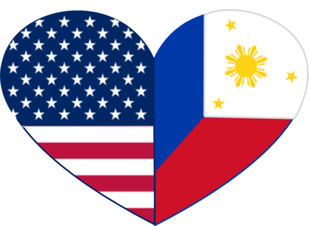
We aim to build a Filipino-American Patient-Centered Outcomes Research (FA-PCOR) villages or nayon in 5 US States (CA, HI, TX, NY, and NJ) to engage Filipino-Americans in discussion of current, salient, and pressing issues in Filipino-American healthcare including, but not limited to, health issues, access to care, community resources, and research engagement.

Eligibility Criteria
Filipino-Americans
Stakeholders of Filipino-American health

Compensation
$10 online gift card will be given to participants

If you are interested in participating, please contact:
Dr. Katherine Abriam-Yago
Katherine.Abriam-Yago@sjsu.edu

Alternative contact at national level:
Dr. M. Danet Lapiz-Bluhm, PhD, MSCI, RN
210-567-5790 or Fil.Am.PCOR@gmail.com
